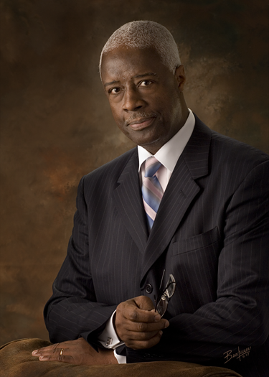
Rev. Larry S. Bullock, MPA\MDiv, [‘73], President, Roosevelt University Alumni Association [RUAA], Former Board Member of the Roosevelt University Board of Trustees; Senior Pastor/Founder, Living Faith Cathedral Worship [LFCWC Church], and Owner and President, April Cobra Enterprises, Inc. [Construction Management, General Contracting, and Real Estate Development firm], Barrington, Illinois. Founder\President, U. S. Minority Contractors Association.

Formerly, National Manager-Strategic Relationships-Stewart Title Company [Multicultural Markets Development, Stewart Title Guaranty Corporation]. His primary responsibilities included multicultural market development and development of strategic relationships with Banking, Investment and Commercial entities within the MCM niches nationwide; he also served on the SISCO National Multi-Cultural Market Advisory Board that consist of 12 members from across the nation. Stewart Title Guaranty [SISCO] is the third largest real estate settlement services-technology corporation in America, based in Houston, Texas [www.stewart.com.].

Previously served for eight years with distinction in the Illinois State House of Representatives and continues to remain active in national - community affairs and Ecumenical work. Pastor Bullock, President/CEO of April Cobra Enterprises, Inc. and Former Chairman, Heartland Energy Technology [H.E.A.T LLC] which specializes in Construction Management, Environmental Engineering, General Contracting, Real Estate Development and global venture consulting. He is the recipient of scores of national and state awards for outstanding accomplishments and achievements in the public policy field, business innovations and economic development arena and Christian missionary endeavors.

As the original founder and current President of the U S Minority Contractors Association [USMCA], he extends his professional expertise to help small emerging Minority owned and operated firms throughout the Chicago land area and nationally. He is past recipient of the Presidential Award from the National Association of Real Estate Brokers [NAREB], designated as the “Democracy in Housing Award” for outstanding and exemplary contribution to the nationwide homeownership campaign in the African American and multicultural market communities. He served on the NAREB, PAC Committee as a national legislative policy advisory to NAREB President and the NAREB Executive committee. He also served on the SISCO National Advisory Multi-Cultural Market Advisory Board. He received the 2006-2007, SuccessGuide Worldwide Magazine [www.fraser.net.com], “Top Achievers” award as a global leader in business networking. Also, his alma mater, Roosevelt University, selected him to serve on the University Board of Trustees after being elected President of the global Alumni Association [RUAA]. He is a nationally sought after motivational speaker and Gospel Preacher.

Pastor Bullock is the Founder, Senior Pastor/Teacher of Living Faith CWC Church, Schaumburg. In that capacity, he was the former weekly radio host of “The Faith Factor: Jew and Christian In Dialogue” along with Co-Host Rabbi Max Weiss. This popular show-program was previously heard each Sunday evening on Radio Station WYLL [AM 1160] throughout the Chicago land. He subsequently hosted, “Real Estate Made Easy” for Stewart Title Guaranty Corp. and it was also heard each Saturday morning from 10:AM-11:AM reaching 1.5 million listeners weekly over WYLL Radio.

Pastor Bullock holds undergraduate Bachelors of Art Degree from Catawba College, where he was the first AA Graduate. {Co-incidentally, he was the first AA Graduate of Mount Airy High School, Mount Airy, N.C. as well}. He holds Two Masters' degrees, receiving his Masters of Divinity Degree from McCormick Theological Seminary, Chicago and a Masters of Public Administration Degree from Roosevelt University, Chicago. A native of Winston –Salem, NC, he is married to Dr. Gloria E. Bullock, DDS, has two children and six grandsons, Rick, Armand, Avery, Jayden Lawrence, Alton Reed and Julian Emanuel.

